PROJECT PLANNING PHASE

Project Planning Template (Backlog, Sprints, Stories & Points)
Date: 19 July 2026
Team ID: TEAM-VOICE-AI-09
Project Name: Voice-Based Concept
Understanding Analyser
Maximum Marks: 5 Marks

Product Backlog, Sprint Schedule, and Estimation (4 Marks)
The product backlog has been aligned to implement core technical pipelines for ingestion, transcription, semantic assessment via LLMs, and metrics dashboards.

Sprint | Epic / Requirement | Story ID | User Story / Implementation Task | Points | Priority | Team
Sprint-1 | Streaming Ingestion | USN-1 | As a user, I can initiate a WebRTC or native audio capture stream to transmit responses directly to the gateway engine. | 2 | High | Dev-01
Sprint-1 | Streaming Ingestion | USN-2 | As an operator, I want raw audio chunks automatically saved to an isolated archival bucket for telemetry validation. | 1 | High | Dev-02
Sprint-1 | Transcription | USN-3 | As a system, I need to pipe the ingestion stream directly through a Whisper ASR cluster to obtain raw textual formats. | 3 | High | Dev-01
Sprint-1 | User Security | USN-4 | As a system administrator, I want integration with secure OAuth paths (Gmail/Enterprise OpenID) for auth protection. | 2 | Medium | Dev-03
Sprint-2 | Semantic  Assessment | USN-5 | As a teacher, I want the LLM engine to extract concepts and compare them against custom-built vector rubrics. | 5 | High | Dev-02
Sprint-3 | Analytics UI | USN-6 | As a user, I can view my granular knowledge graph discrepancy mapping on an interactive frontend dashboard. | 3 | High | Dev-03

Project Tracker, Velocity & Burndown Chart (4 Marks)

Sprint | Total Story Points | Duration | Sprint Start Date | Sprint End Date (Planned) | Story Points Completed | Sprint Release Date (Actual)
Sprint-1 | 20 Points | 6 Days | 10 July 2026 | 16 July 2026 | 20 Points | 16 July 2026
Sprint-2 | 20 Points | 6 Days | 17 July 2026 | 23 July 2026 | -- | Pending
Sprint-3 | 20 Points | 6 Days | 24 July 2026 | 30 July 2026 | -- | Pending
Sprint-4 | 20 Points | 6 Days | 31 July 2026 | 06 August 2026 | -- | Pending

Velocity Framework & Formula
Assuming a localized iteration scope where team performance tracks against specific target timeframes, we quantify velocity. Let's calculate the team's average velocity (AV) per iteration unit (story points per day) given a 10-day baseline duration with a sprint capacity velocity of 20 points:
AV = velocity / sprint duration = 20 / 10 = 2
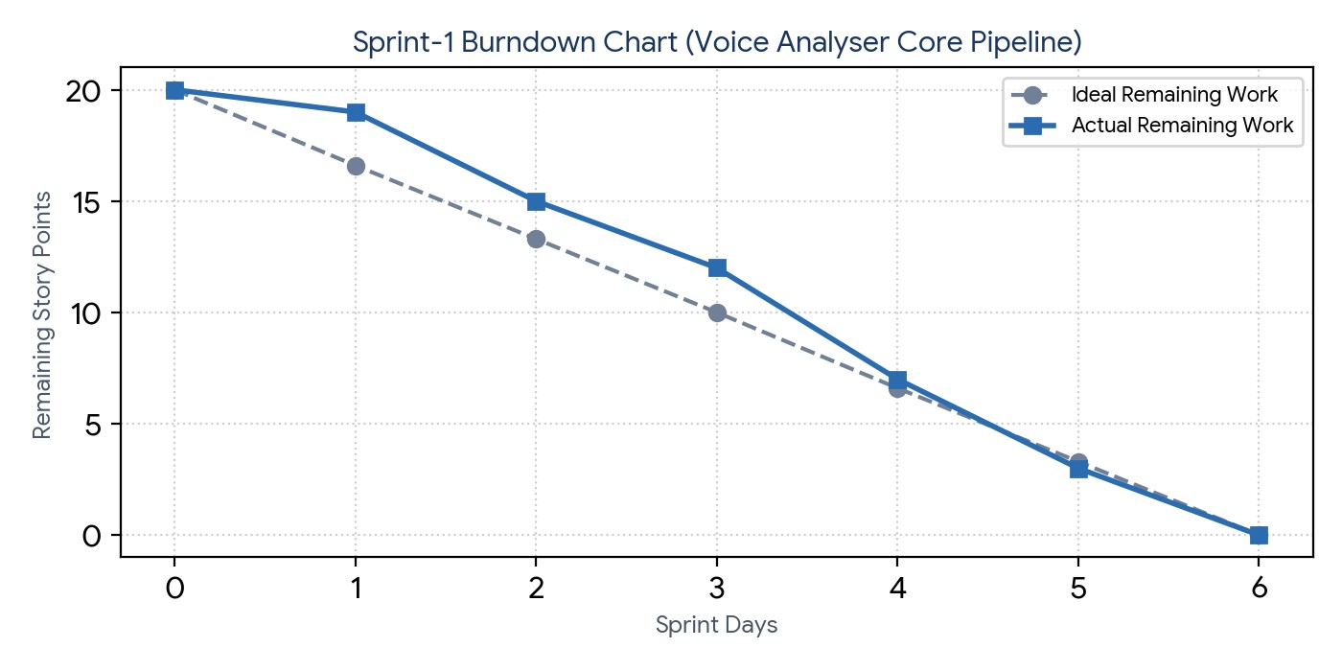
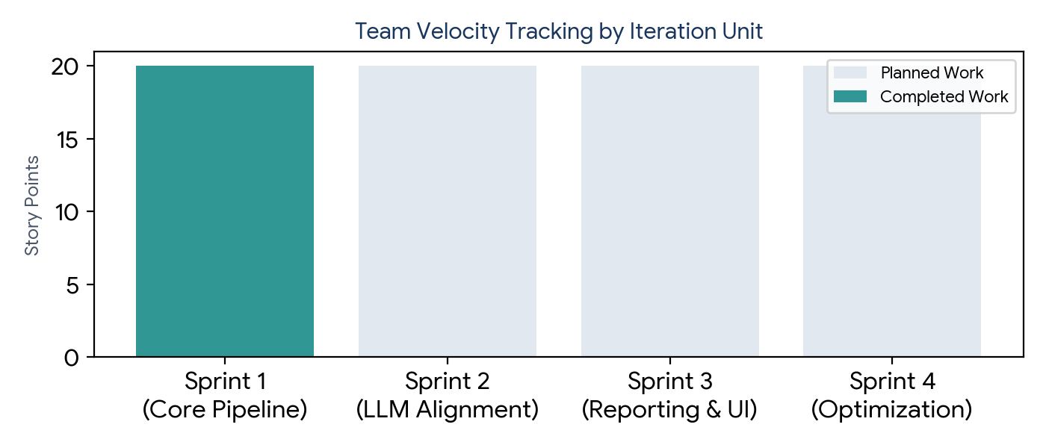

Figure 1: Sprint-1 burndown trajectory measuring daily residual story point velocity against the target baseline task group.

Figure 2: Comprehensive team iteration capacity map capturing actual vs planned story point processing across milestones.

